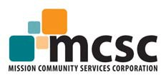

SUCCESS STORY GUIDE QUESTIONS

Success Story Information
Business Owner’s Full Name and Title:
Business Name:
Address:
Phone:
Email:
Ownership:

Personal Information/Background (Are they a Veteran, Female Owner, etc? Where did they grow up? etc.)

What/When was your first business aspiration? (How’d they get started?):

What/How was the process of starting your business?

How did SBA and/or our partners assist you along the way?

What did you learn? Would you change anything if you were starting over today?

What’s your favorite part about your job? The most difficult aspect?

What makes your business unique/special/important to the community?

How many employees do you have? Have you had an increase in employees/sales?

What advice would you give another entrepreneur trying to start their own business?

